Blockchain-Powered Charity NFT Auctions: A Transparent and Immutable Platform for Donation Verification

In propose work we are utilizing Blockchain technology to manage NFT based charitable fund raising auctions. In the past existing applications were utilizing Centralized server to manage all fund raising data but centralized server database can be easily tamper with the help of server database administrator and raised funds can be misused and manipulated. Currently no tool exists to detect server database tampering.

To avoid such tampering we are employing Blockchain server which has inbuilt support for decentralized, secured and tamper proof data storage.

**Decentralized means**: Blockchain will replicate or store data at multiple nodes once data block successfully mined. If one node down Blockchain can access data from other working nodes so it’s called as Decentralized storage

**Secured Storage**: Blockchain store each data block in encrypted format

**Tamper Proof Storage**: Blockchain store each record as transaction/block and associate each block with unique hash code and this hashcode will get verify for each subsequent block storage, if data alter in any block then result into different hashcode and data tamper will get detected. This proof of work make Blockchain tamper free storage.

**What is an NFT?**

In the most basic sense, NFT means a non-fungible token is a way to store data on a Blockchain such as Ethereum. Unlike a fungible asset like a US dollar, one NFT cannot be swapped interchangeably for another NFT. That’s because each token functions as a way to validate unique ownership of something, such as a single work of digital art.

Blockchain can store and retrieve data using Smart Contract which can be designed using Solidity programming. This contract contains functions definition which can be called with any programing language to store and retrieve data. In propose work to manage all NFT based auctions and donations we have designed following contract

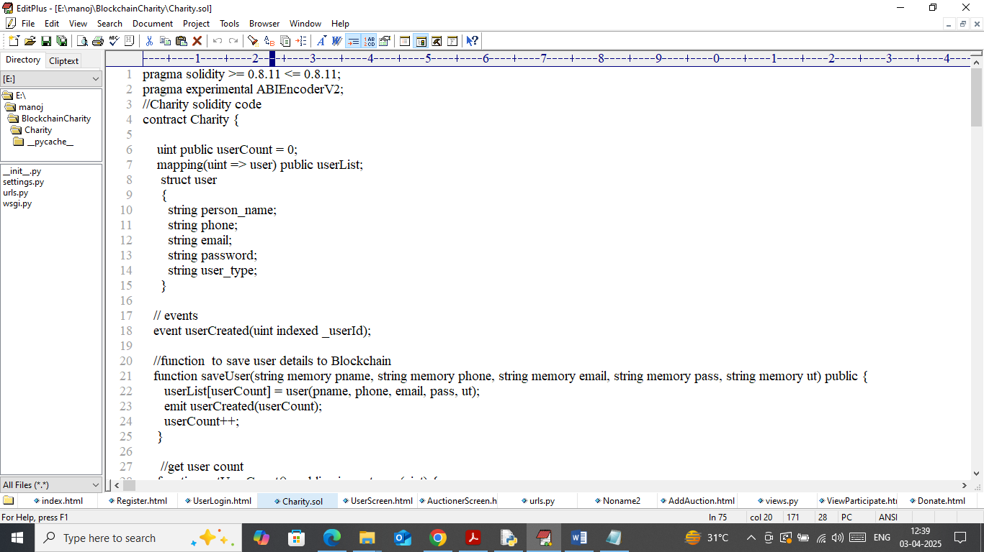

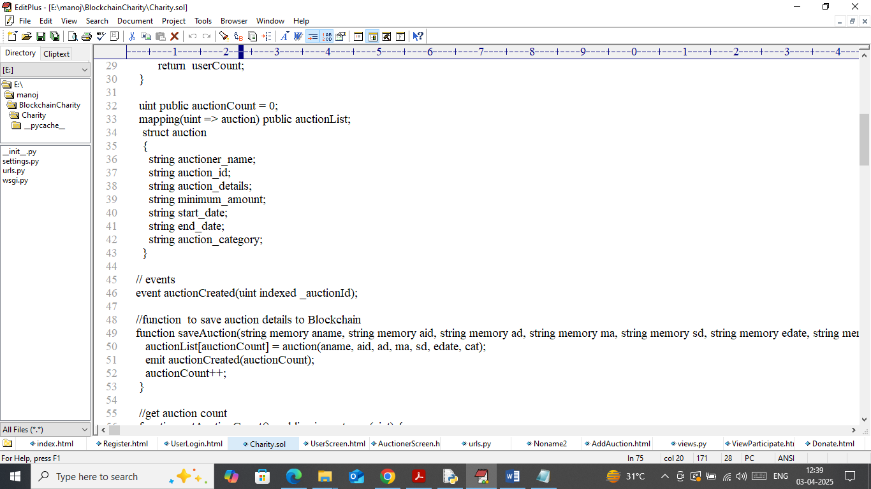

In above contract code we have designed functions to manage user details, auctions, bid, donation and NFT transactions. Now we need to deployed above contract to Ethereum Blockchain using below steps

1. First go inside ‘hello-eth/node-modules/bin’ folder and then look and double click on ‘runBlockchain.bat’ file to get below page
2. 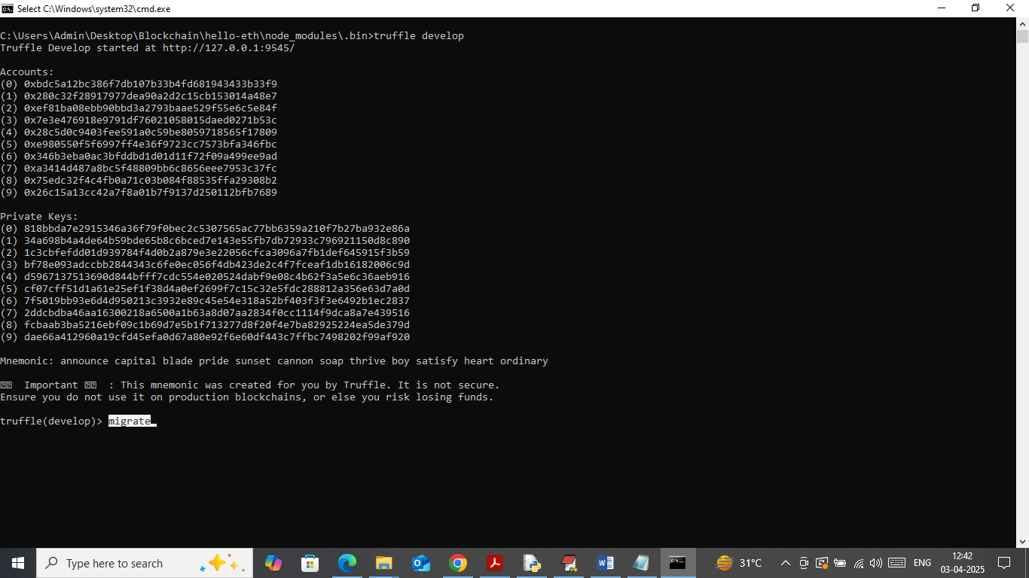
3. In above screen Ethereum started with default private keys and accounts and now type command as ‘migrate’ and then press enter key to deploy contract and then will get below page
4. 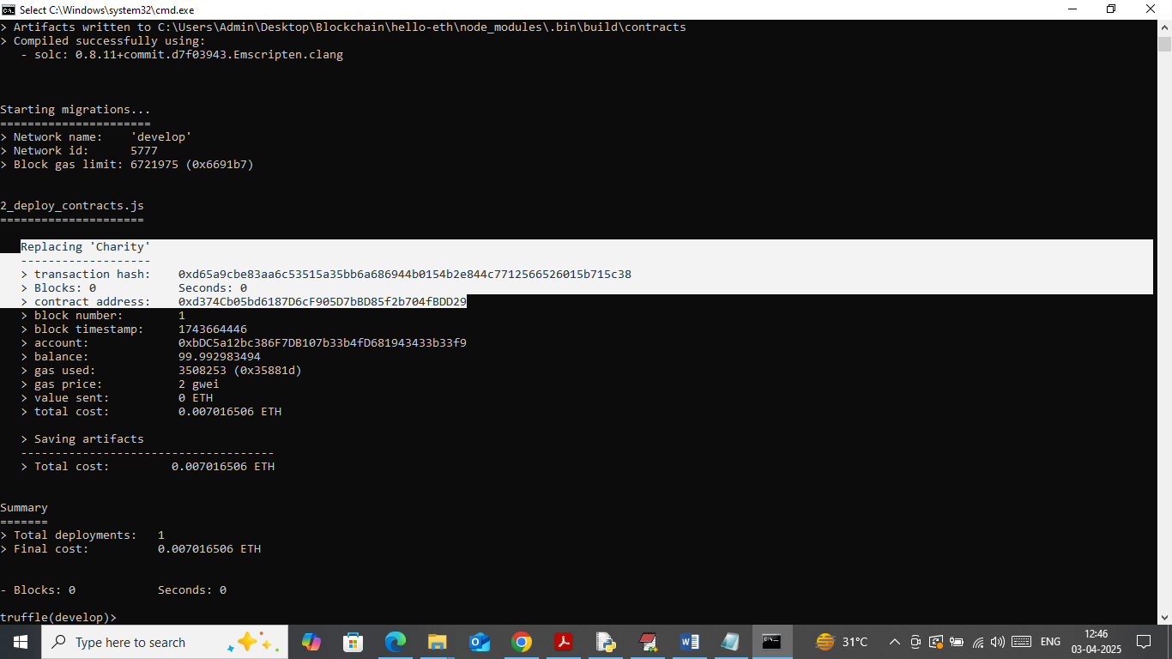
5. In above screen in white text can see ‘Charity’ contract deployed and running successfully and got contract address and this address need to specify in python code to call contract to save and get data. In below screen showing python code calling above contract using address
6. 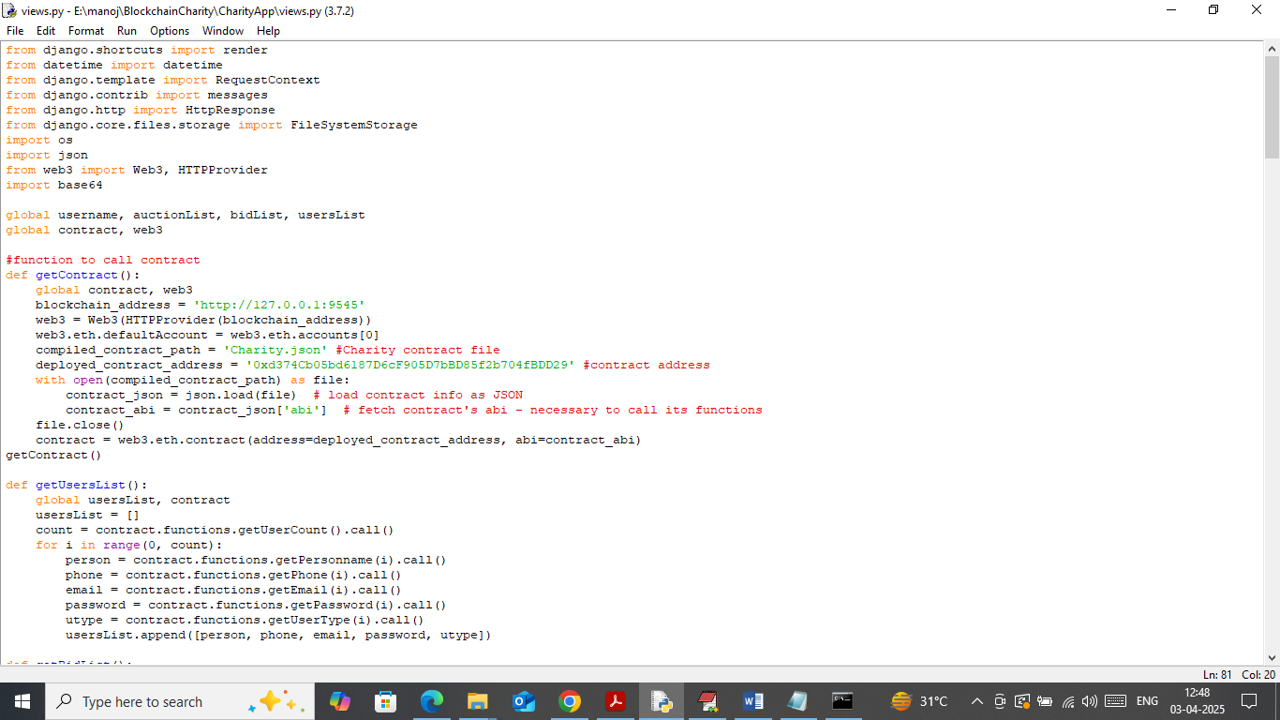
7. In above screen read red colour comments to know about contract calling using address. In above black console contract running successfully and let it run till you execute completed project.

To manage NFT auction fund raising we have designed following modules

1. New User Signup: both donors and auctioner can sign up with the application and all details will get saved in Blockchain
2. Auctioner Login: auctioner can authenticate himself with the Blockchain and then execute below modules
3. Add Charity Auction: after login auctioner can add new charity details to Blockchain and for each auction unique charity id will be generated and then mention charity cause along with auction details
4. View Donor/Bidder Participation: auctioner can view list of participant with total fund raise amount
5. Donor Login: donor can authenticate with Blockchain and then execute below
6. Browse Cause List: after login bidder/donor can browse list of causes and then can donate for desired cause.

SCREEN SHOTS

To run project install python 3.7.2 and then install packages given in requirements.txt file and then follow instrcutions.txt file to execute code.

Now double click on ‘runServer.bat’ file to start python web server and then will get below page

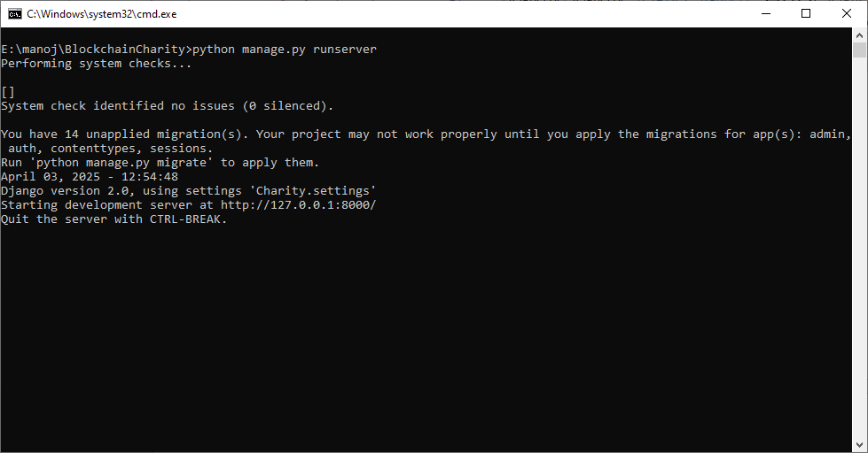

In above screen python server started and now open browser and enter URL as <http://127.0.0.1:8000/index.html> and then press enter key to get below page

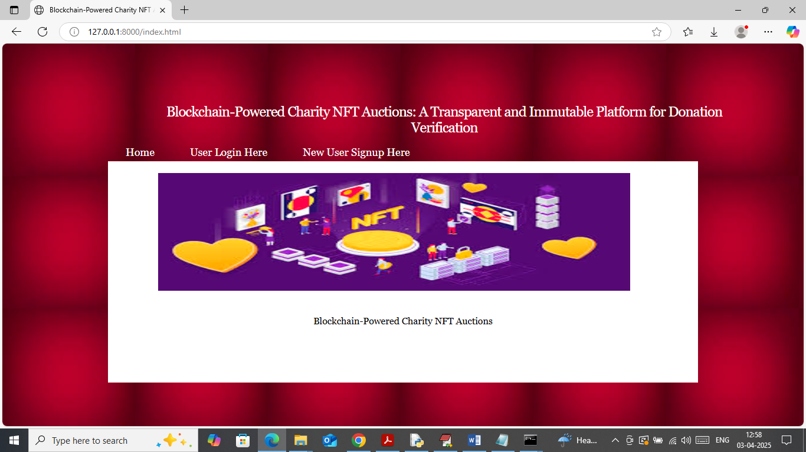

In above screen click on ‘New User Sign up’ link to get below page

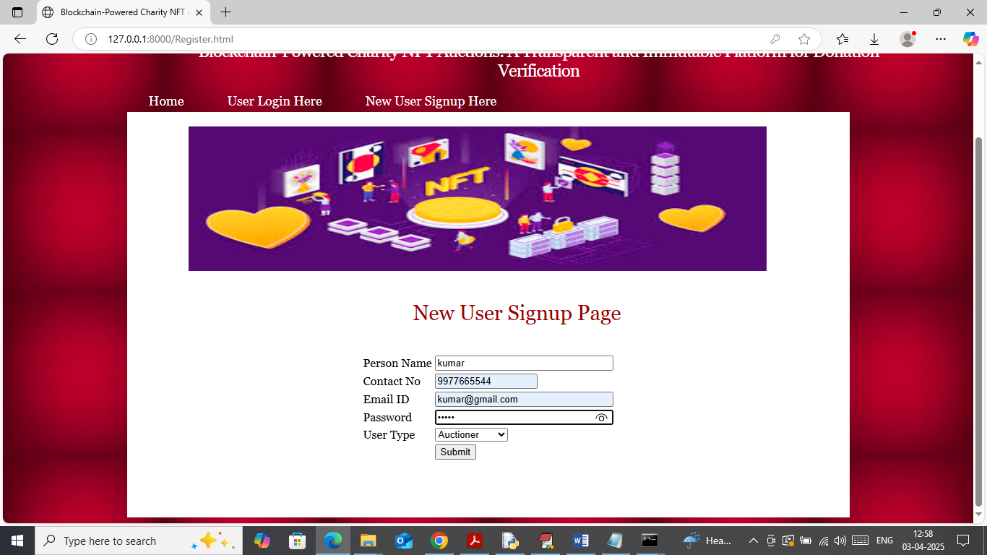

In above screen auctioner is getting registered and then press button to save details in Blockchain and then will get below page

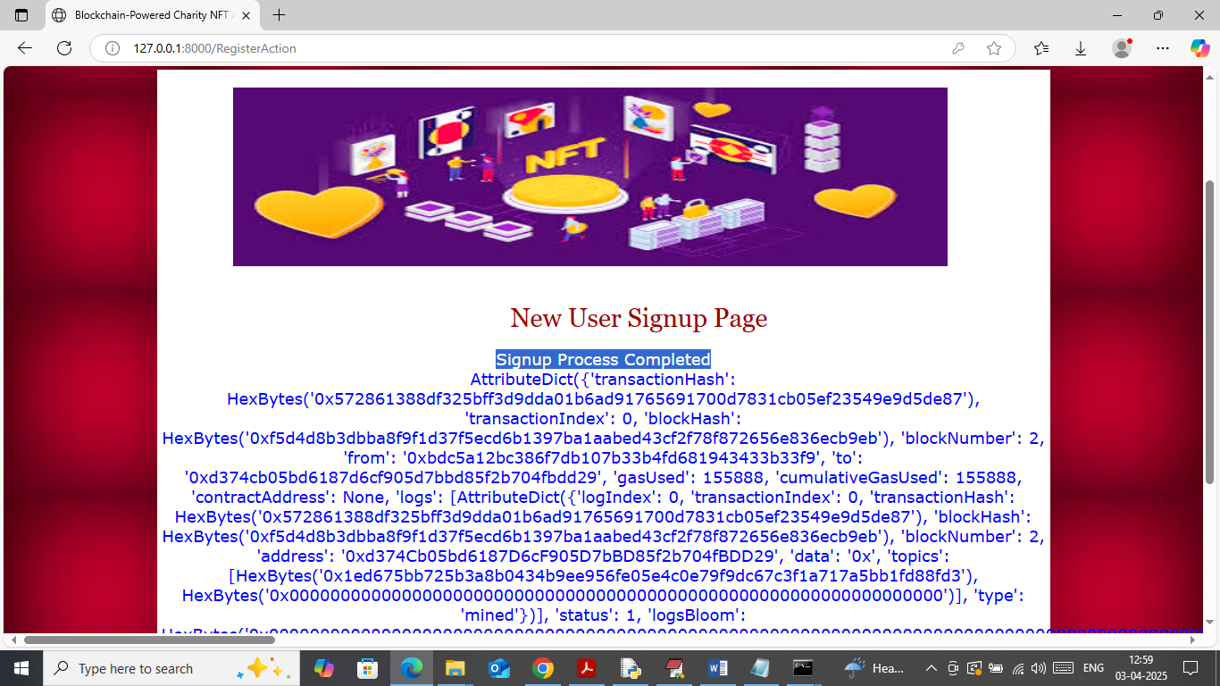

In above screen user sign up completed and then I am displaying entire log obtained from Blockchain after storage. This log contains details like Block no, transaction no, hash code and many other details. Similarly you can add as many users as you want

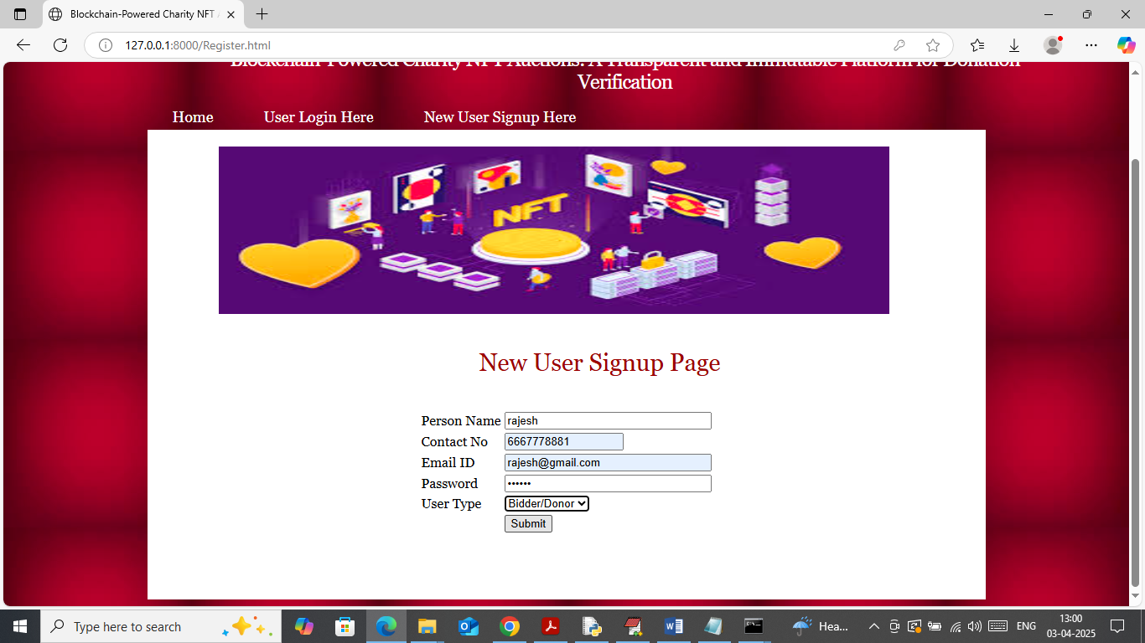

In above screen adding donor/bidder details and then press button to get below page

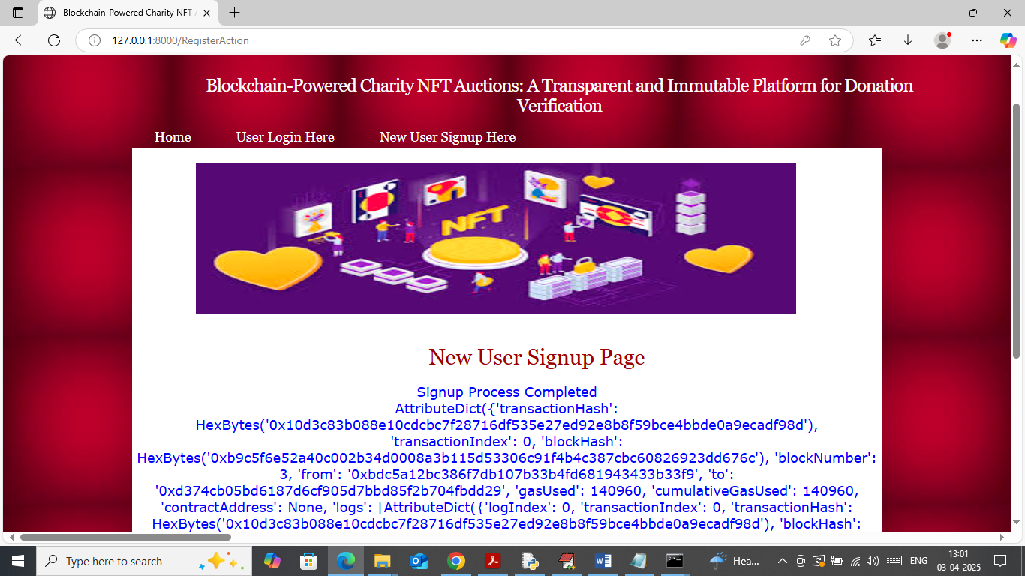

In above screen donor/bidder details added to Blockchain and now click on ‘User Login’ link to get below page

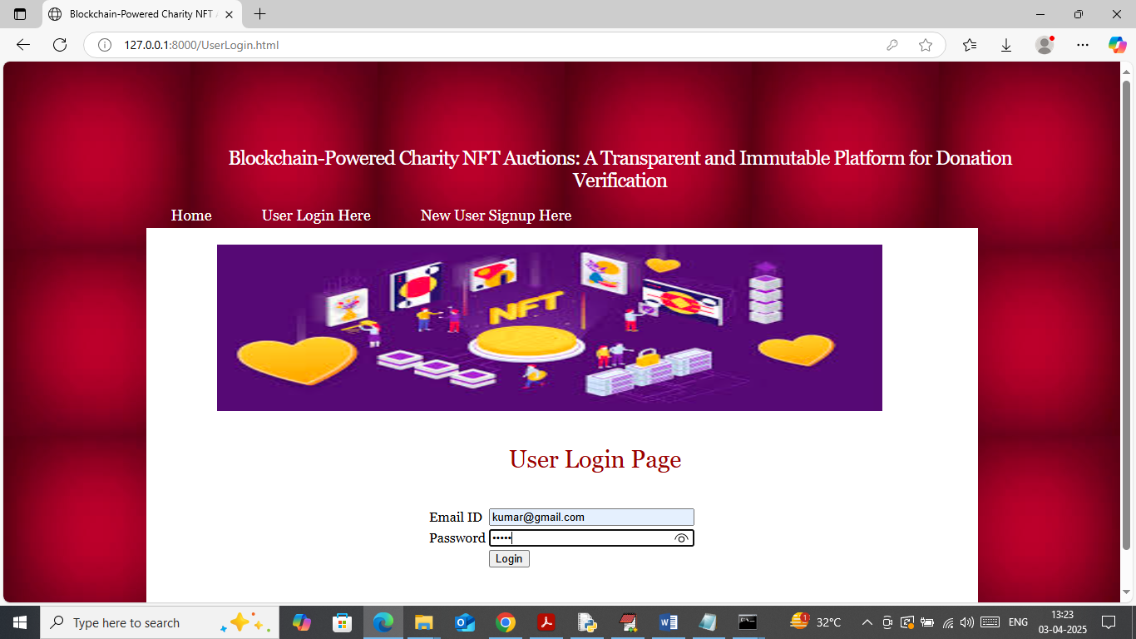

In above screen Auctioner is login and after login will get below page

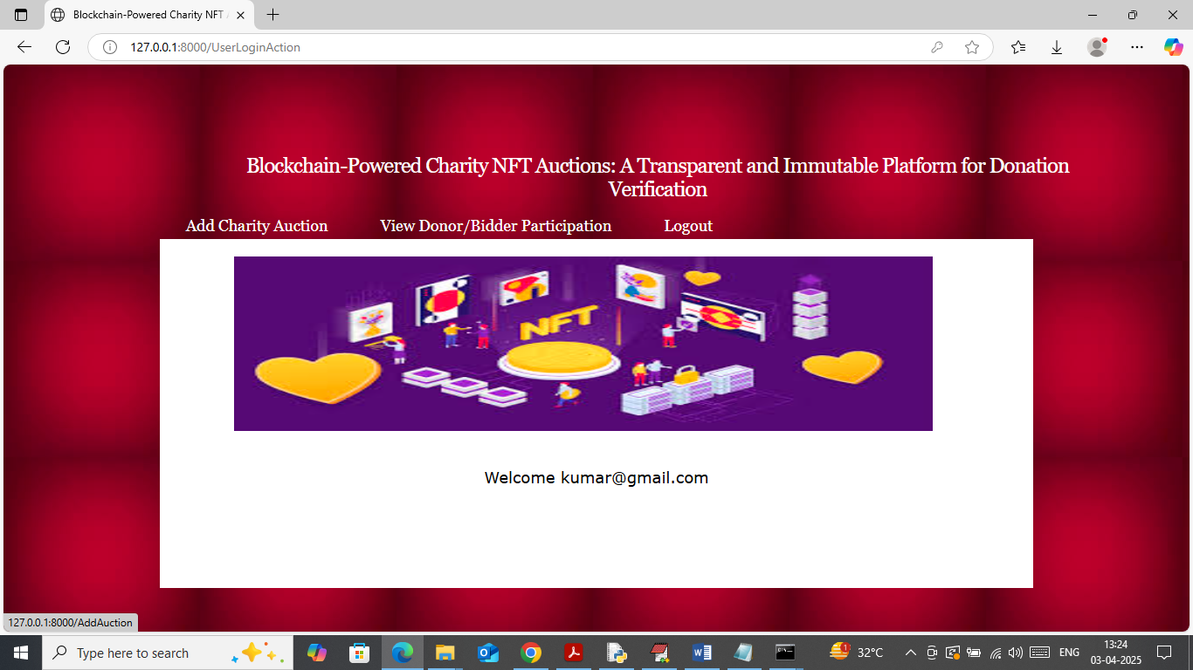

In above screen auctioner can click on ‘Add Charity Auction’ link to add fund raising charity details and then will get below page

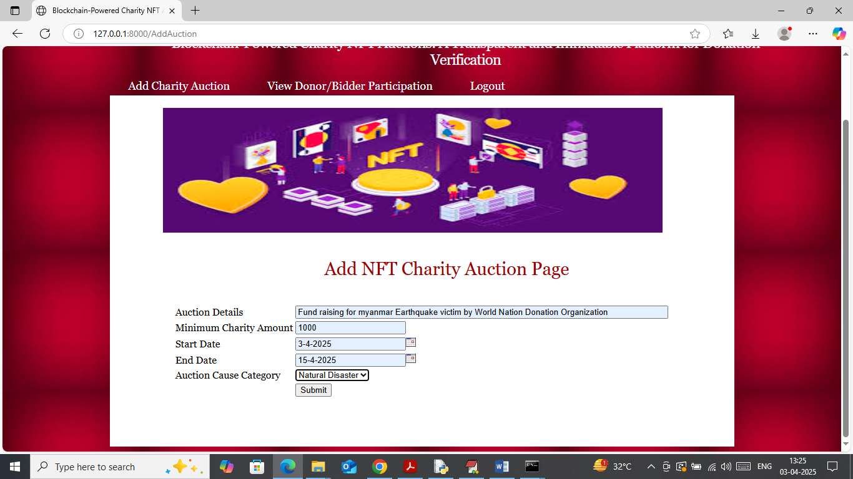

In above screen auctioner can add details of charity cause along with date and cause category and then press button to get below page

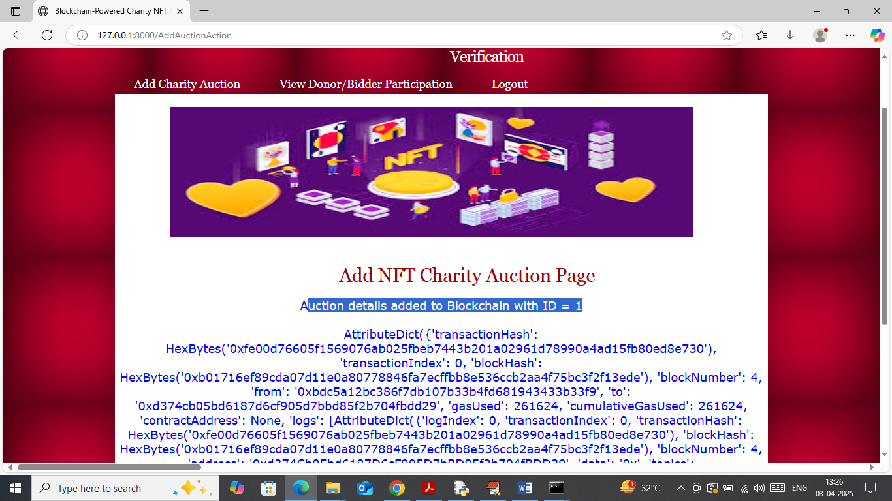

In above screen charity auction details added to Blockchain with auction id as 1 and similarly you can add as many auctions as you want. Now logout and login as donor/bidder to make donation

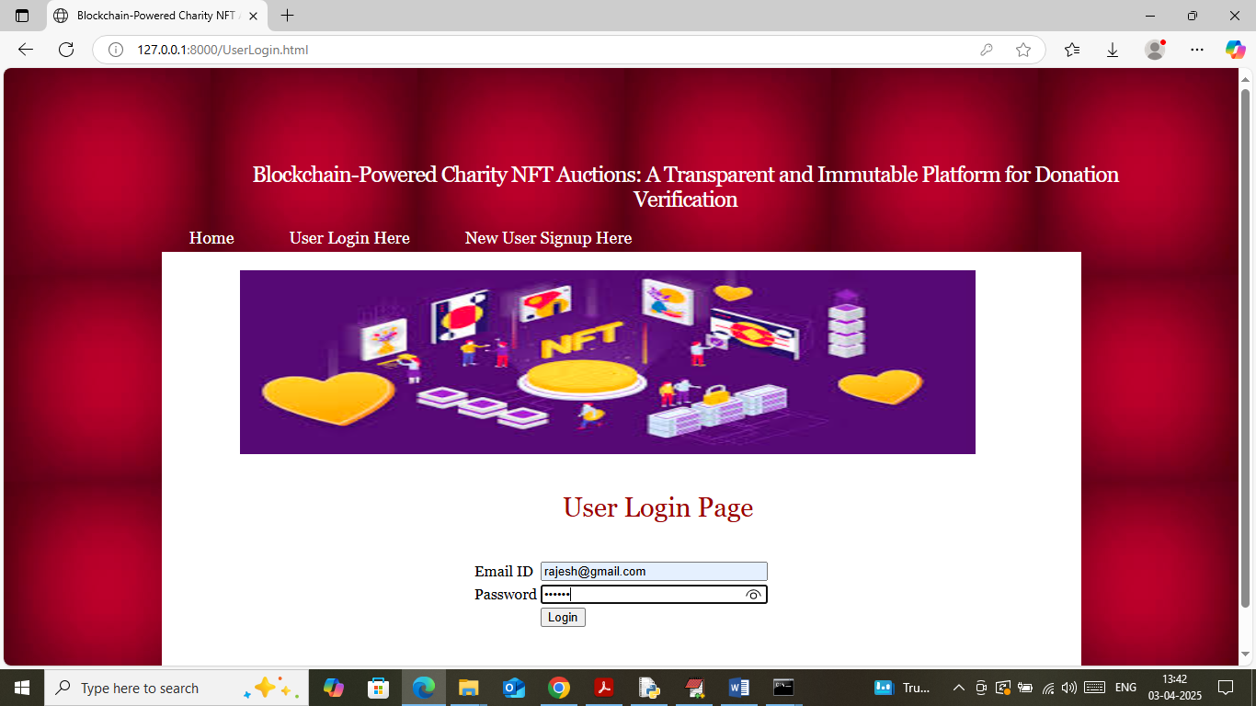

In above screen donor is login and after login will get below page

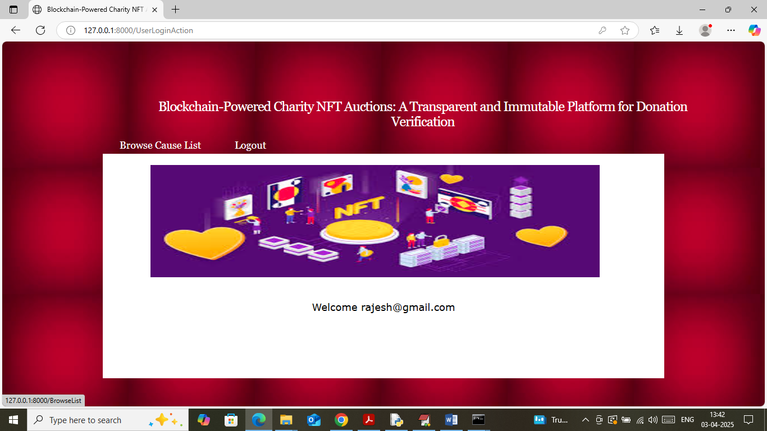

In above screen donor can click on ‘Browse Cause List’ link to view list of different auction causes like below page

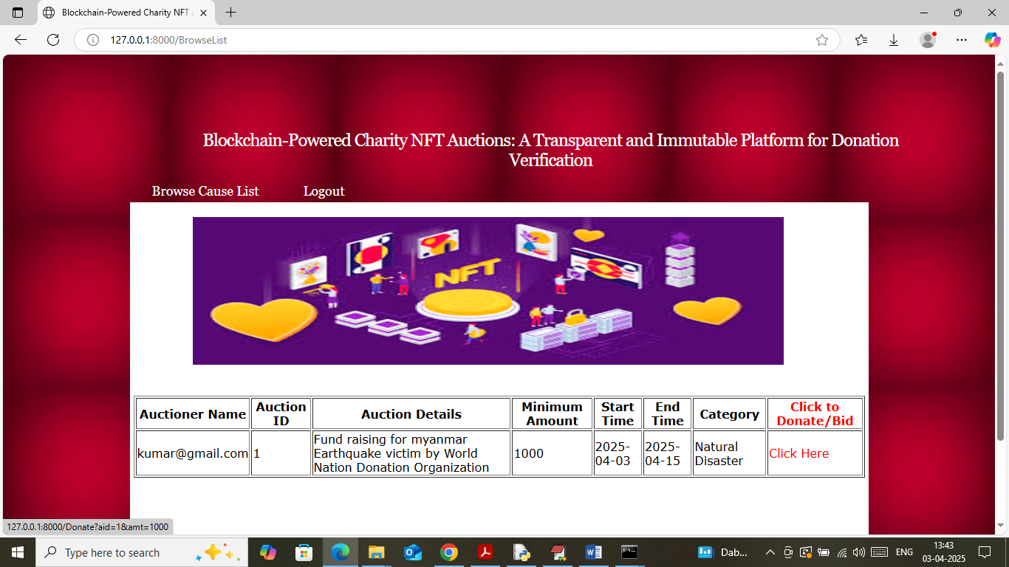

In above screen donor can view list of all auction can causes and can donate to desired auction by clicking on ‘Click Here’ link and then will get below page

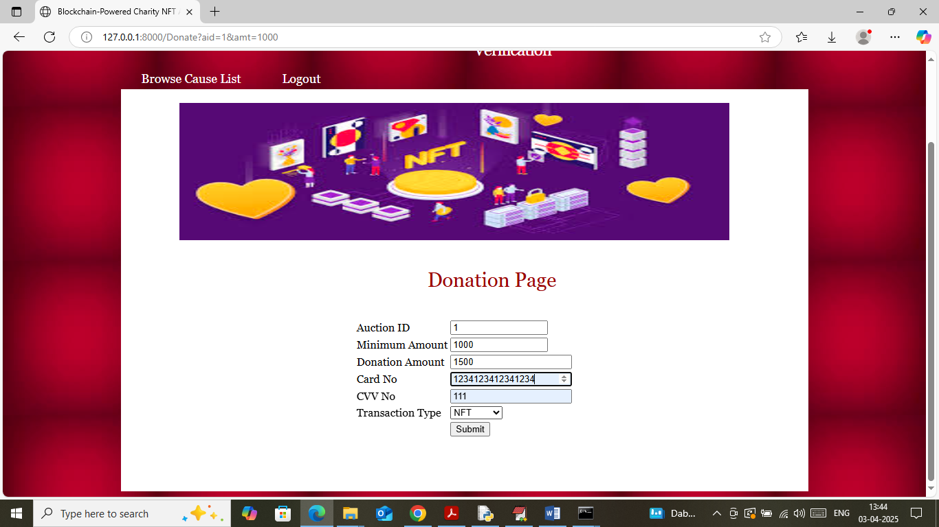

In above screen donor can view selected auction ID along with minimum amount and then can donate desired amount and then press button to record donation to Blockchain and then will get below page

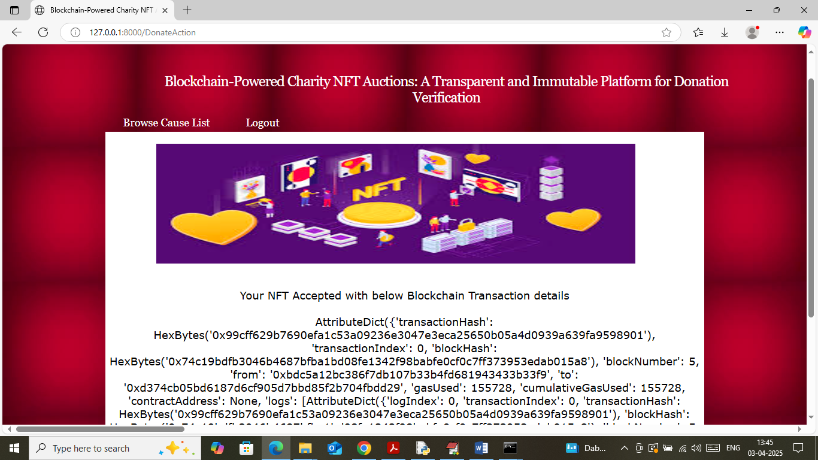

In above screen transaction successfully recorded in Blockchain and similarly any number of users can make donation and now logout and login as ‘Auctioner’ to view total raised amount

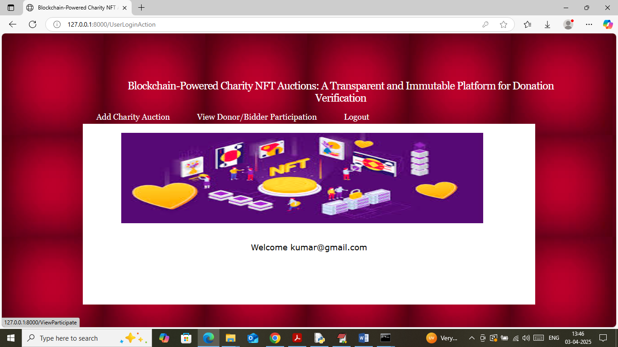

In above screen auctioner can click on ‘View Donor/Bidder Participation’ link to get below page

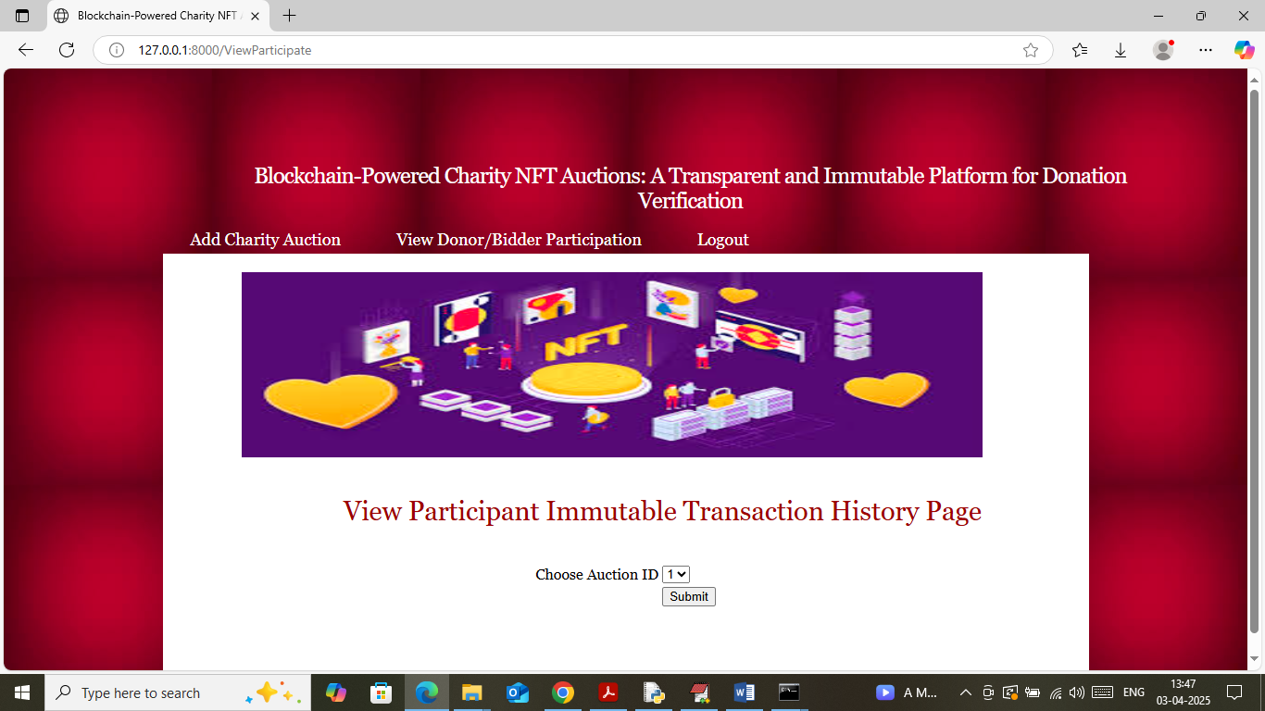

In above screen auctioner can select desired auction id and then press button to get below fund raising amount

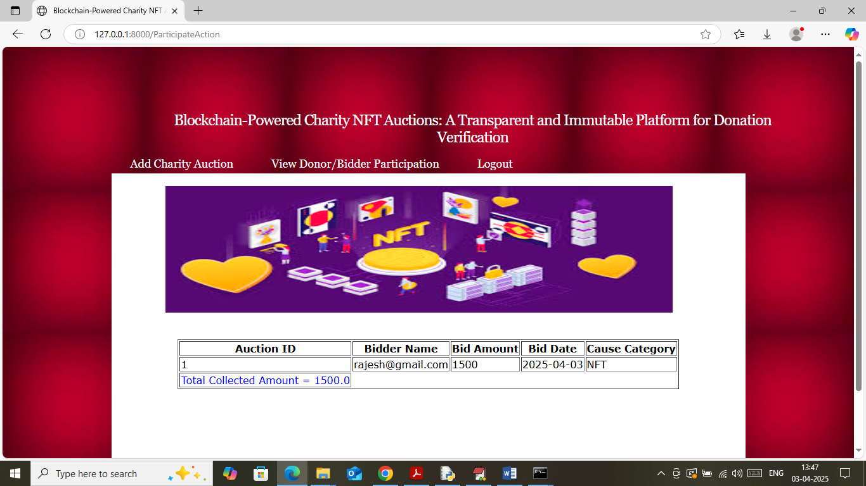

In above screen in table format auctioner can see list of donor transaction details along with total amount collected.

So using above application both auctioner and donor can record all auction fund raising transaction to Blockchain without fear of tampering